Project Proposal

Project Name: North Fork Cabin Creek Culvert Replacements

Project Sponsor:
Grande Ronde Model Watershed Foundation (GRMWF)
1114 J Avenue
La Grande, OR 97850
541-663-0570
541-962-1585 (f)

Participating Landowners and Agencies
Grande Ronde Model Watershed Program (GRMWP)
Union County PWD
Robert Wheeling (landowner)
Anderson Perry & Associates (designs)

Project Contact(s):
Grande Ronde Model Watershed Program (technical)
- Lyle Kuchenbecker, 541-663-0570, lyle@grmw.org

Grande Ronde Model Watershed Foundation (administrative)
- Lyle Kuchenbecker, 541-663-0570, lyle@grmw.org
- Mary Estes, 541-663-0570, mary@grmw.org

Project Location:
The project area descriptions for the culverts are:

Site 1 Robinson Road (south site)
Legal description: T3N, R39E, Sec. 35, NE ¼ of the SW ¼

Site 2 Private drive (middle site)
Legal description: T3N, R39E, Sec. 26, SW ¼ of the SW ¼

Site 3 Robinson Road (north site)
Legal description: - T3N, R39E, Sec. 26, NW¼ of the SW ¼

Introduction and Background
The project proposes to replace three culverts with channel-spanning bridges, arches or bottomless concrete box culverts. North Fork Cabin Creek is habitat for summer steelhead, resident rainbow and other native fish. All culverts are partial to complete barriers (depending on flow) to adult steelhead passage. All are complete barriers to juvenile steelhead and resident fish. Two of the culverts are on a county road, one is a private drive. The North Fork Cabin Creek, at the project sites, is an intermittent stream, usually ceasing to flow in late July or early August. Flow in the headwater tributaries is perennial and provides year-long steelhead rearing and resident fish habitat.

Project Objectives:
- Provide year-round fish passage for all life stages of all native species, particularly Snake River summer steelhead
- Maintain streambed stability

Proposed Actions:
- Remove existing culverts
- Construct and remove bypass (site 2 only)
- Realign streambed to conform with stream form and function above and below the sites (probable at Site 3 only)
- Install rock cross vane grade control structures as necessary to stabilize streambed (may be above and/or below the bridge sites
- Construct new structures (steel bridges at Sites 1 & 3, bottomless arch at Site 2)
- Erosion seed disturbed ground, reestablish hardwoods
- Grade and resurface the gravel roads

Benefits
Replacement of the three culverts in combination will open access for steelhead to approximately 5.5 miles of headwater habitat. Larger capacity crossing structures will reduce risk of failure and introduction of sediment and road fill into the system.

Monitoring
Union County PWD and GRMW will annually inspect the structure for evidence of undermining or damage to protective armouring. GRMW will annually inspect the streambed above and below the site for evidence of down-cutting or excessive bedload accumulation. GRMW will annually inspect rock vanes for compliance with fish passage criteria.

Construction is proposed for the in-water work period July 1 to October 15, 2010. The channel is expected to be dry during the construction period. Anderson-Perry & Associates (AP) of La Grande, Oregon have completed a site survey, preliminary designs and final designs. AP will prepare and submit DSL and COE permit applications. ESA consultation will be completed via BPA’s HIP II. Cultural Resource survey and SHPO Section 106 compliance will be subcontracted.

Appendix

Vicinity Map
Pre-project picures
Budget (separate Excel file)

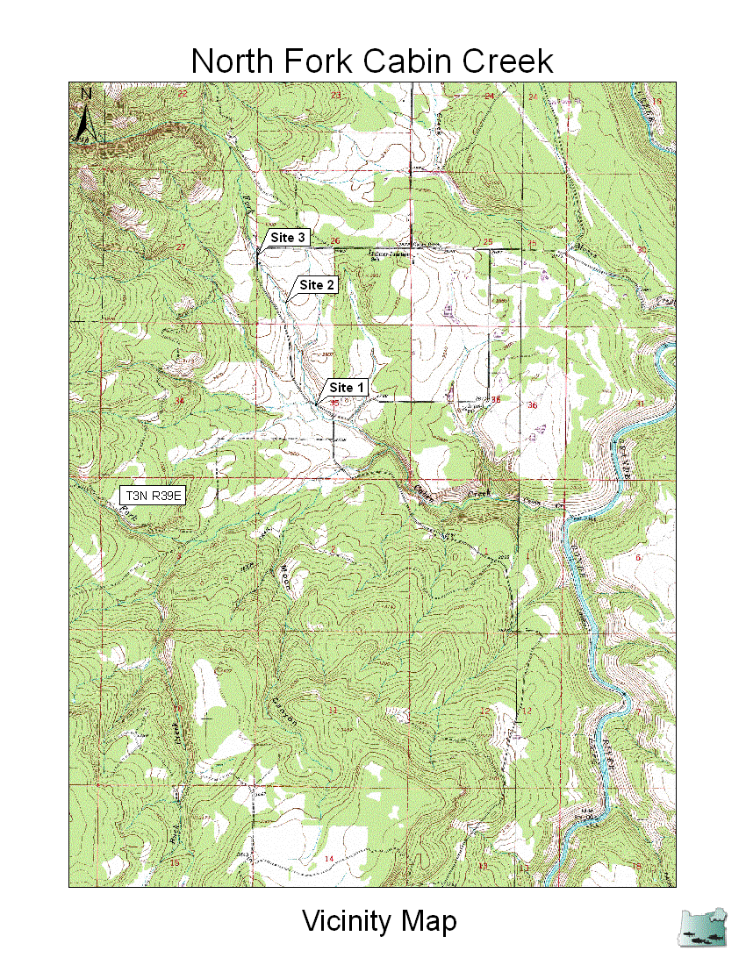

Site 1
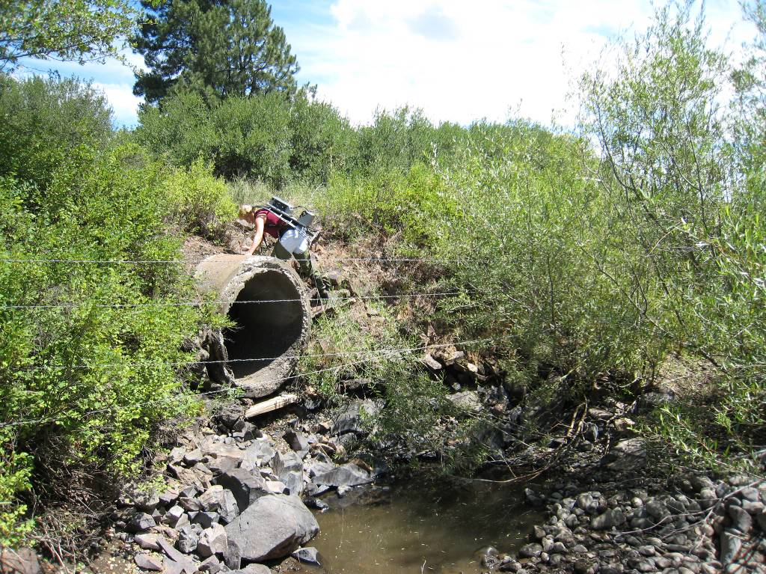

Site 2
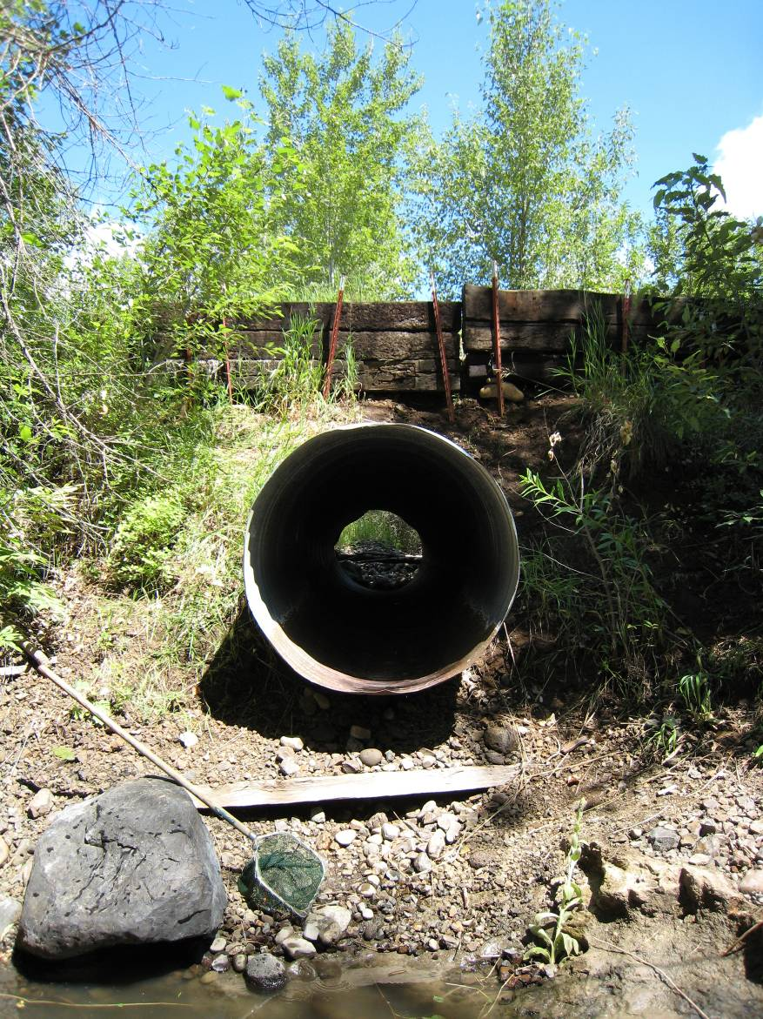

Site 3
